35.12: The width of a bright fringe can be defined to be the distance between its two adjacent destructive minima. Assuming the small angle formula for destructive interference
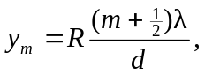
the distance between any two successive minima is
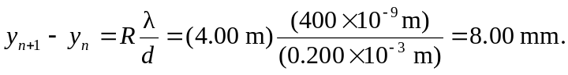
Thus, the answer to both part (a) and part (b) is that the width is 8.00 mm.

